🧪 PRACTICALS USING SUPERMARKET DATA

1️⃣ DESCRIPTIVE STATISTICS

🧠 Concept
Descriptive statistics summarize data using measures like mean, median, variance, and standard deviation.

💻 Code
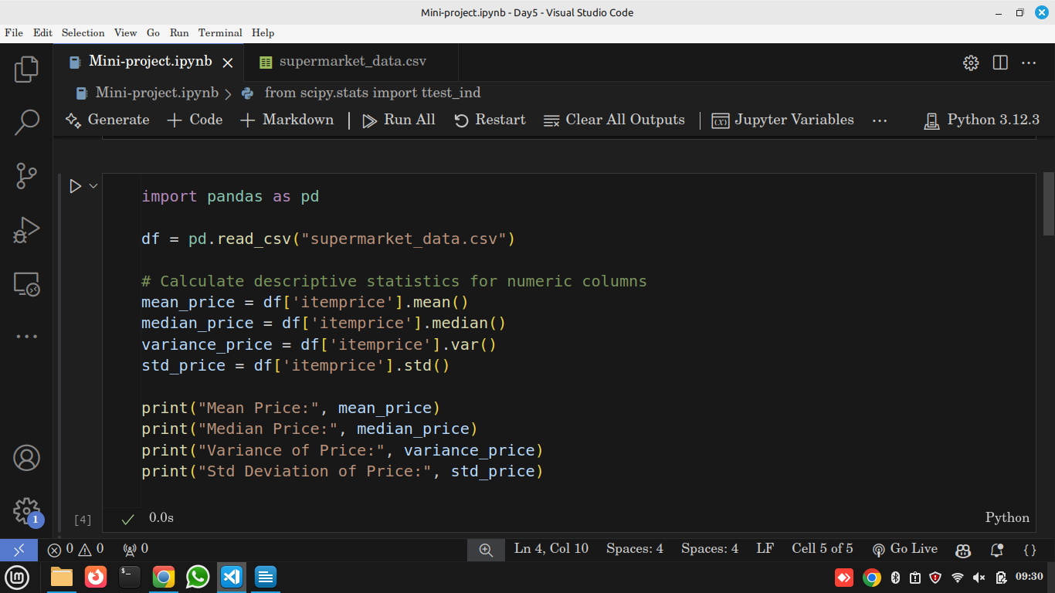

🧾 Code Explanation
- .mean() → Average price
- .median() → Middle price
- .var() → Measures spread of prices
- .std() → How much prices vary on average

📊 Business Insight
A high standard deviation means customers buy products with very different prices. A low value means prices are consistent.

2️⃣ PROBABILITY DISTRIBUTIONS (Normal, Binomial, Uniform)

🧠 Concept
- Normal: Bell-shaped (e.g., customer spending)
- Binomial: Success/Failure (e.g., male vs female buyers)
- Uniform: Equal chance (e.g., random sampling)

💻 Code
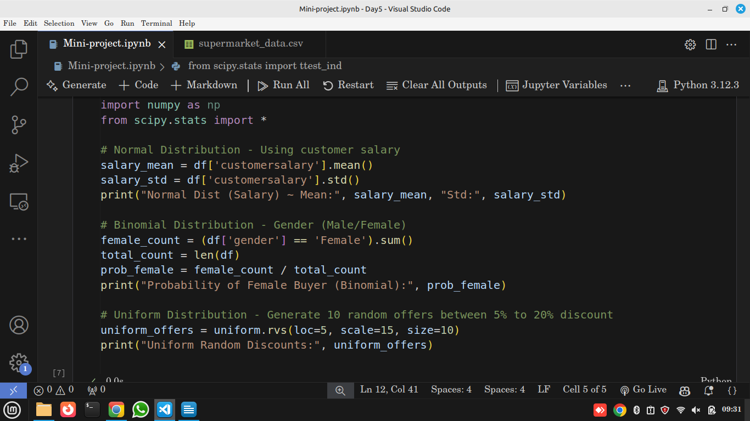

🔍 Insight
- Normal: Salaries cluster around average.
- Binomial: Helps estimate customer demographics.
- Uniform: Used for random promo generation.

3️⃣ INFERENTIAL STATS (Sampling & Confidence Intervals)

🧠 Concept
We use sample data to estimate population parameters with confidence.

💻 Code
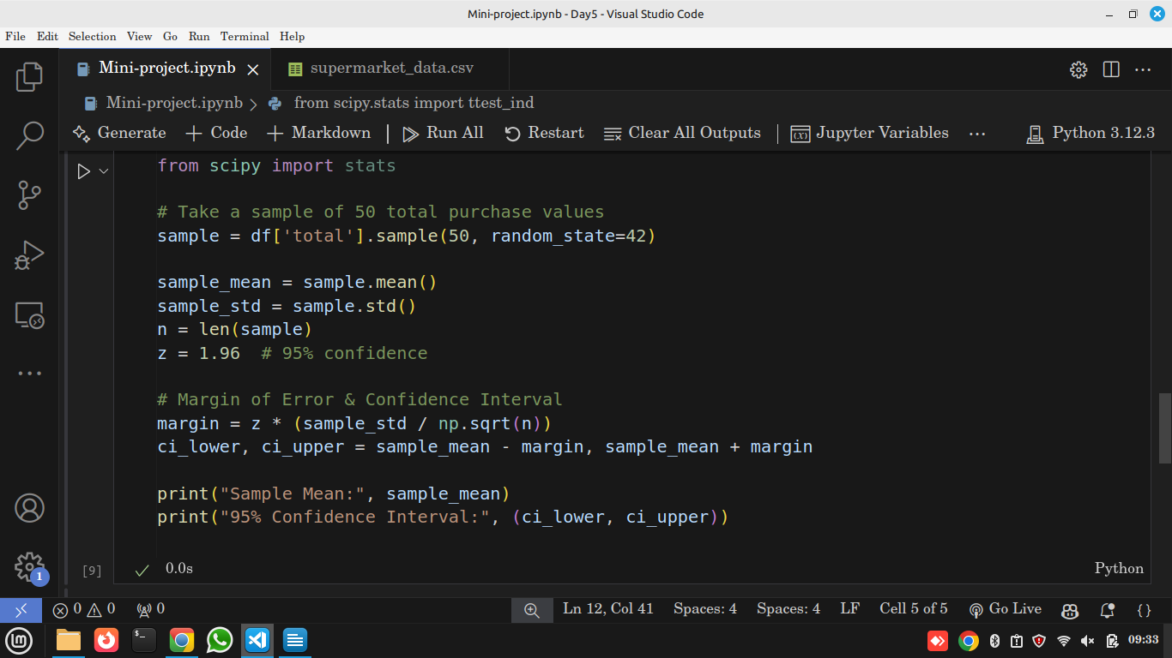

🧾 Explanation
- Sample → Partial data
- CI → Estimated range of true average spending

💡 Insight
“We are 95% confident that true customer spending lies between these two values."

4️⃣ HYPOTHESIS TESTING (t-test & Chi-Square)

🧠 Concept
Used to check claims or compare groups.

🔹 t-Test Example (Male vs Female Spending)
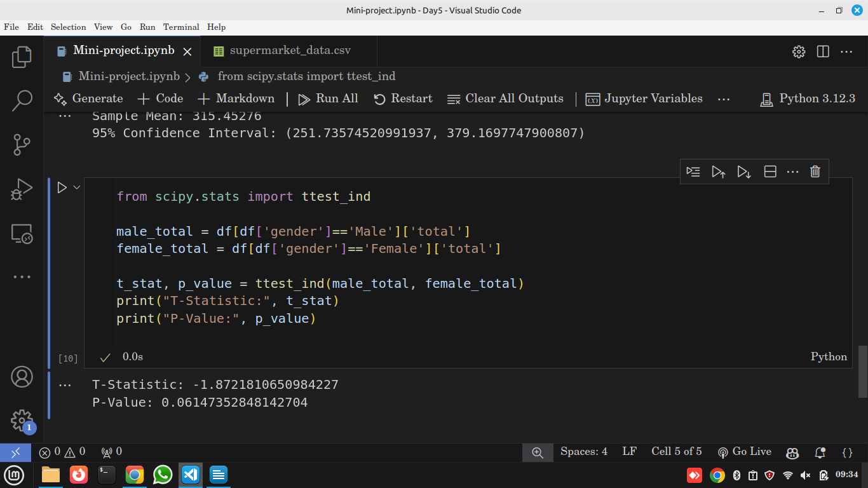
Insight: If p-value < 0.05, spending is different between genders.

🔹 Chi-Square Test (Gender vs Product Preference)
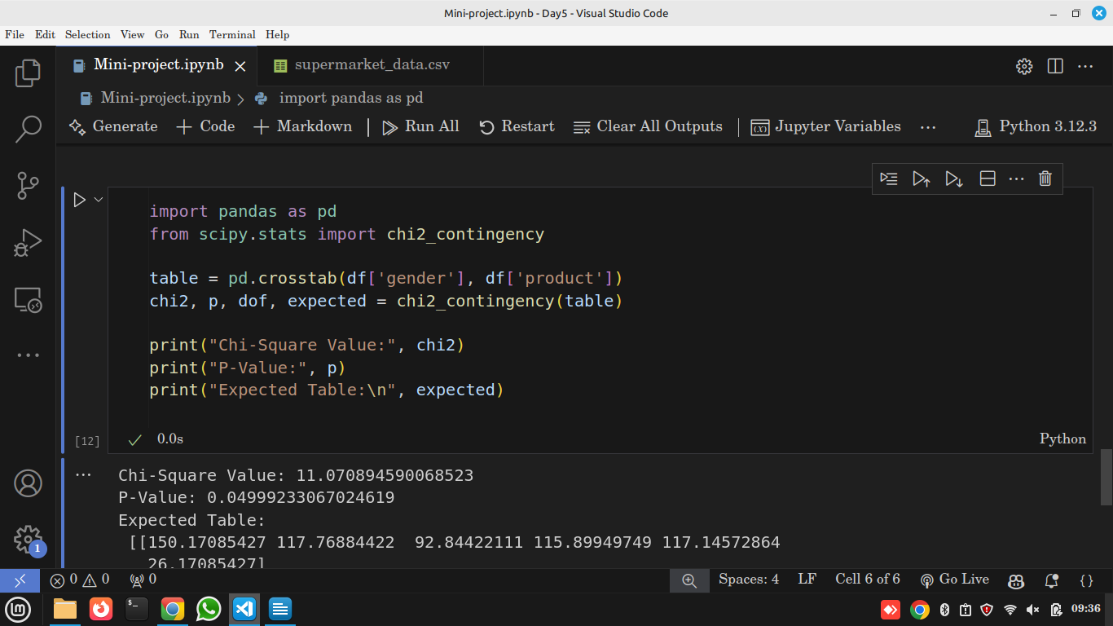
Insight: If p < 0.05, product preference depends on gender.

📝 Final Assignment
1️⃣ Perform t-test for rating between Male and Female.
2️⃣ Perform Chi-Square test for payment method and gender.

